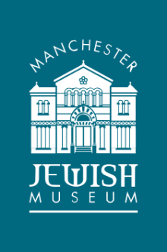

KS3 Judaism is lively and fun at Manchester Jewish Museum
Following the success of our Jewish Faith sessions for KS1 and 2, MJM have been busy developing new sessions for KS3.
Pupils who took part in these KS3 sessions in summer 2016 enjoyed the lively and interactive delivery.
They enjoyed learning about Judaism in the surroundings of a former Sephardi synagogue with all its key features. They loved the team games, the chance to handle unfamiliar objects, time to explore the building and freedom to ask questions.
They came away with information about
- the Torah and how it is central to Jewish life
- the role of the Synagogue and its features
- how Jewish articles of prayer are used
- how Jewish festivals are celebrated
Give your pupils a learning experience with real impact by booking online at http://www.manchesterjewishmuseum.com/learning-at-manchester-jewish-museum/
For further information contact the Learning Officer
Email: andrea@manchesterjewishmuseum.com Phone: 0161 830 1433

